GTAS

Business Registry

Revision History
Date | Version | Description | Author
12-Sep-03 | 1.0 | Initial draft | Neo Sok Lay

Table of Contents
1. Introduction 4
1.1 Purpose 4
1.2 Scope 4
2. Overview of Requirements 4
3. Technical Specifications 5
3.1 GridTalk Published TModels 5
3.2 DUNS Identification Scheme 5
4. Registry Connection Information 6
4.1 Authentication and Authorization 6
4.2 Persistence 6
4.3 User Interface Requirements for Registry Connection Information 6
5. Publishing Registry Information 8
5.1 JAXR – GridTalk Information Model Mapping 8
5.2 Storing Publish Registry References 8
5.3 User Interface Requirements for Publishing 9
6. Configure Partner from Inquired Registry Information 11
6.1 Search Criteria 11
6.2 Search Results 11
6.3 Configuring as partner 12
6.4 User Interface Requirements for Submit Search 14
6.5 User Interface Requirements for Display Search Results 16
6.6 User Interface Requirements for Display Searched Business Entity 17
6.7 User Interface Requirements for Display Communication Channel 18
7. Synchronizing Registry Information 22
7.1 Upward Synchronization 22
7.2 Downward Synchronization 22
8. Implementation Issues 23
8.1 Partner Category 23
8.2 Downward Synchronization Scheme 23
8.3 Registry Provider API 24
Appendix A: Mapping of Registry Information Models 25

Introduction

Purpose

This document describes the Business Registry feature in GTAS, as of version 2.2, for UDDI support. It is meant to serve as a reference on the technical design decisions taken or to be considered during the development of the feature.

Scope

This document covers only the high-level UI and design requirements and some technical details on the with regard to the data models involved, and does not cover the architectural design of the module.

Overview of Requirements

In general, the Business Registry module in GridTalk will support the following functions:
- Allow the GridTalk users to publish business and service information to a registry using the configured entities in GridTalk.
- Allow the GridTalk users to query from the registry for potential partners who have published their business and service information using function 1.
- Allow the GridTalk users to use the queried registry information from function 2 to configure entities in GridTalk.
- Allow the Gridtalk users to synchronize published (function 1)/inquired (function 3) registry information to/from a registry.

These functions will enable Partners to be easily configured for transacting RNIF or SOAP messages. The Business Registry will be based on the JAXR information model. Refer to Mapping of Registry Information Models for a comparison of the information models provided by GridTalk, WSRA, JAXR, and UDDI. JAXR technical specifications can be found at http://java.sun.com.

Technical Specifications

GridTalk Published TModels

GridTalk will publish the following TModels to a given UDDI registry:
- GridTalk Messaging Standards (namespace) [gridnode-com:messagingStandards]
  - Description e.g. Messaging Standards supported in GridTalk
  - Namespace classification under [uddi-org:types] classification scheme
  - RNIF 2.0 messaging (fingerprint) [gridnode-com:rnif-2]
    - Overview URL e.g. www.rosettanet.org/rosettanet/Doc/0/TAO5O8VV3E7KLCRIDD1BMU6N38/ RNIF2.1.pdf
    - Protocol classification under [uddi-org:types] classification scheme
  - RNIF 1.1 messaging (fingerprint) [gridnode-com:rnif-1.1]
    - Overview URL e.g. www.rosettanet.org/rosettanet/Doc/0/TAO5O8VV3E7KLCRIDD1BMU6N38/ RNIF2.1.pdf
    - Protocol classification under [uddi-org:types] classification scheme
  - SOAP messaging over HTTP (fingerprint) [gridnode-com:soap-http]
    - Overview URL e.g. http://www.w3.org/TR/SOAP/
    - Protocol classification under [uddi-org:types] classification scheme
- GridTalk Business Identifiers (namespace)
  - Description e.g. Business Identifiers used in GridTalk
  - Can be used for creating identifier bag for the published business information, e.g.
    - “Enterprise Id”,
    - “Business Entity Id”,
    - “Global Supply Chain Code”,
    - “PO Box”
    - “Language”
    - “Website”
  - Identifier classification under [uddi-org:types] classification scheme

DUNS Identification Scheme

The DUNS identification scheme is made a core part of every UDDI registry. As such, the GridTalk Business Registry would identify each published or queried Business Entity using the universal unique DUNS identification scheme:
- UUID: “uuid:8609C81E-EE1F-4D5A-B202-3EB13AD01823”
- Name: “D-U-N-S”

Registry Connection Information

Authentication and Authorization

In order to submit, update, or delete registry information, authentication is required when using the publishing API of the registry. There are various authentication methods and the most common is the user name and password authentication method. GridTalk Business Registry will only cater for this authentication method at this stage.

Authorization checks are performed by specific registries and thus are not within the scope of GridTalk Business Registry.

Persistence

In order to enhance usability, the GridTalk Business Registry will allow the users to manage Registry Connection Information so that these can be re-used when required, for example, during publishing or querying.

name | Name to identify the connection
queryUrl | URL to query from registry
publishUrl | URL to publish to registry
publishUser | User name for authentication at the registry for publishing
publishPassword | Password for authentication at the registry for publishing

User Interface Requirements for Registry Connection Information

Figure 1 shows the UI concept of the registry connection information management function. The following paragraphs explain the requirements in more detail for the creation. Update, retrieval and deletion should be similar to the management of other types of entities.

Entry Conditions:
User clicks "Create Registry Connect Info" on Registry Connect Info List page.

Inputs & Interface Processing Requirements:

Name: Name of the Connect Info.

Query URL: URL to use for querying from the target registry.

Publish URL: URL to use for registering to the target registry. The resource URI may be different from Query URL.

User Name: User name for authentication by the target registry.

Password: Password for authentication by the target registry.

Save: Submits for saving

Cancel: Cancels the operation

Exit Conditions:
Returns to Registry Connect Info List page.

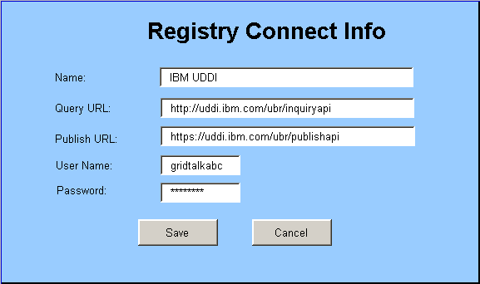
Figure 1 Managing Registry Connect Info

Publishing Registry Information

JAXR – GridTalk Information Model Mapping

GridTalk will allow the user to publish the configured Business Entity(s) to a given registry as business and service information:

Business Information

JAXR model (Organization) | GridTalk Model (Business Entity)
name | description
description | whitePage.busDesc
telephoneNumbers | -
primaryContact | contact information from whitepage (contactPerson, tel, email, fax)
postalAddress | address information from whitepage
classifications (categoryBag) | -
externalLinks (discoveryURLs) | -
externalIdentifiers (identifierBag) | Create one external identifier each for:  - “Enterprise Id” (enterpriseId),  - “Busines Entity Id” (busEntId),  - “Global Supply Chain Code” ( whitepage.globalSupplyChainCode)  - “PO Box” (whitepage.poBox)  - “Language” (whitepage.language)  - “Website” (whitepage.website)  using the “GridTalk Identifiers” classification scheme (tModel).  Create one external identifier for:  - “DUNS number” (whitepage.duns),  using the “D-U-N-S” classification scheme.

Service Information

JAXR model (Service) | GridTalk Model
name | e.g. “Messaging Service”
description | e.g. “Service for transacting messages”
serviceBindings (bindingTemplates) | Channels assigned to the Business Entity (pick those with RNIF or SOAP packaging only)
Service Binding | Channel Info
description | name
accessURI (accessPoint) | URL in Comm Info of Channel Info
specificationLinks (tModelInstanceDetails) | Reference to respective TModel details based on Packaging envelope.

Storing Publish Registry References

At publishing time, if the TModels that need to be referenced are not already published in target registry, they will be published and the registry reference will be stored in a Registry Object Mapping table:

registryObjectKey | Key to identify the published TModel
registryQueryURL | URL to query the object from registry
registryPublishURL | URL to publish the object to registry
registryObjectType | ClassificationScheme/Concept
proprietaryObjectType | MessagingStandards/BusinessIdentifiers
proprietaryObjectKey | RNIF2/RNIF1/SOAP/nil
deleted | “false”
published | “true”

After publishing the Business and Service information, the references for respective registry objects will be stored in the Registry Object Mapping table:

registryObjectKey | Key to identify the registry object
registryQueryURL | URL to query the object from registry
registryPublishURL | URL to publish the object to registry
registryObjectType | Organization/Service/ServiceBinding
proprietaryObjectType | BusinessEntity/organization key/ChannelInfo
proprietaryObjectKey | Unique Identifier in proprietary entity type
deleted | “false”
published | “true”

User Interface Requirements for Publishing

Figure 2 shows the UI concept of the publishing function. The following paragraphs explains the requirements in more detail.

Entry Conditions:
User selects one or more Own Business Entity(s) on Own Business Entity List page and clicks "Publish".

Inputs & Interface Processing Requirements:

Business Entity(s): Use for selecting the Own Business Entity(s) to publish.

Available Choice(s) | List of Own Business Entity(s).
Selection(s) | Initially default to selected Own Business Entity(s) in Entry Conditions.
“>>” and “<<” | User can add or remove selection to this list using the ">>" and "<<" buttons.

Registry Connection Information: Use to specify the connection information required in order to publish to a registry.

Connection | List of RegistryConnectionInfo(s) saved previously.  When an item is selected, the Publish Url, Query Url, User name and password will be initialized accordingly.
Publish URL | URL to use for registering to the target registry.
Query URL | URL to use for querying from the target registry.  The resource URI may be different from Publish URL.
User Name | User name for authentication by the target registry.
Password | Password for authentication by the target registry.

Publish: Submits for publishing.

Cancel: Cancels the operation

Exit Conditions:
Returns to Own Business Entity List page.
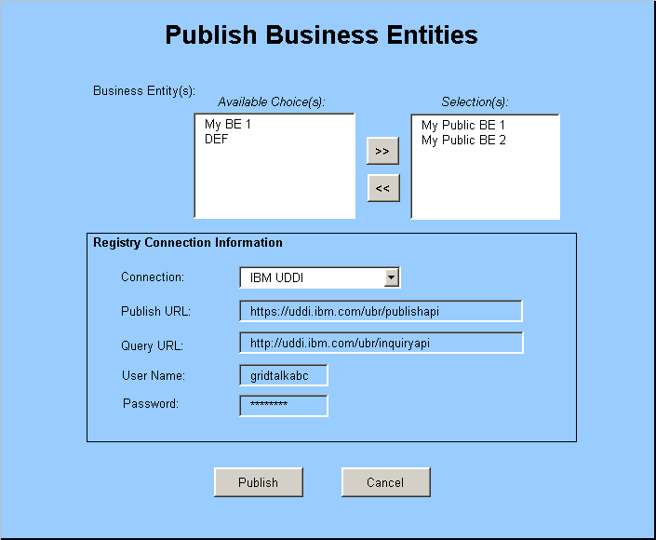
Figure 2 Publish Business Entities

Configure Partner from Inquired Registry Information

Search Criteria

GridTalk will allow the user to search from a given registry for organizations by:
- Organization name (this will correspond to business entity description) – allows partial match of multiple name patterns
- DUNS number (multiple numbers)
- TModel (this will be a selectable list of “GridTalk Messaging Standards” published by GridTalk. Multiple selection.) – this is a mandatory criterion.

Search Results

The returned response from the inquiry will be displayed to the user detailing the following information:

Presented | Value Source
GridTalk Model (Searched Business Entity) | JAXR model (Organization)
busEntId | externalIdentifiers(“Business Entity Id”).value
enterpriseId | externalIdentifiers(“Enterprise Id”).value
uuid | key
description | name + “ (from registry)”
state | NewBe/PartnerBE/MyBe - determined based on enterpriseId
whitePage | See below
channels | serviceBindings from “MessagingService” service. See below.
White page
busDesc | description
contactPerson | primaryContact.personName
tel | primaryContact.telephoneNumber(“Main Tel”).number
email | primaryContact.emailAddresses(0).address
website | externalIdentifier(“Website”).value
address | postalAddress.addressLine.values[0]
city | postalAddress.addressLine.values[1]
country | postalAddress.addressLine.values[4]
zipCode | postalAddress.addressLine.values[3]
state | postalAddress.addressLine.values[2]
poBox | externalIdentifiers(“PO Box”).value
language | externalIdentifiers(“Language”).value
duns | externalIdentifiers(“DUNS number”).value
globalSupplyChainCode | externalIdentifiers(“Global Supply Chain Code”).value
Channel Info | Service Binding
name | description
description | “Channel “ + channelInfo.name + “ (from registry)”
refId | businessEntity.enterpriseId
tptProtocolType | “HTTP”
securityProfile | See below
packagingProfile | See below
tptCommInfo | See below
Security Info
name | channelInfo.name + “.SEC”
description | “Security Profile of ” + channelInfo.name + “ (from registry)”
encryptionType | “None”
signatureType | “None”
refId | businessEntity.enterpriseId
Packaging Info
name | channelInfo.name + “.PKG”
description | “Packaging Profile of ” + channelInfo.name + “ (from registry)”
envelope | specificationLink.name
refId | businessEntity.enterpriseId
isZip | “false”
Comm Info
name | channelInfo.name + “.COMM”
description | “Communication Profile of ” + channelInfo.name + “ (from registry)”
protocolType | “HTTP”
url | accessURI
refId | businessEntity.enterpriseId
tptImplVersion | DEFAULT_TPTIMPL_VERSION

Configuring as partner

GridTalk will allow the user to choose to configure partners based on the registry information inquired from a given registry. Only non-“MyBe” can be configured into the system in this way. The registry references for inquired registry information will be stored to the Registry Object Mapping table.

Persisted | Source
Business Entity | Searched Business Entity
busEntId | busEntId
enterpriseId | enterpriseId
description | description
state | NORMAL
whitePage | whitePage
isPartner | “true”
partnerCategory | “Non-GridTalk”
canDelete | “true”
Registry Object Mapping
registryObjectKey | uuid
registryURL | URL of registry inquired from
registryObjectType | “Organization”
proprietaryObjectType | “BusinessEntity”
proprietaryObjectUId | UID of created Business Entity
deleted | “false”
published | “false”
 | JAXR model (Service)
Create a Registry Object Mapping for the Service
For each serviceBinding in the Service, create a Channel Info.
Registry Object Mapping
registryObjectKey | key
registryURL | URL of registry inquired from
registryObjectType | “Service”
proprietaryObjectType | “MessagingService”
proprietaryObjectUId | Organization.key
deleted | “false”
published | “false”
Channel Info | Channel Info
name | name
description | description
refId | refId
tptProtocolType | tptProtocolType
isPartner | “true”
partnerCategory | “Non-GridTalk”
canDelete | “true”
Security Info | Security Info
name | name
description | description
encryptionType | encryptionType
signatureType | signatureType
refId | refId
isPartner | “true”
partnerCategory | “Non-GridTalk”
canDelete | “true”
Packaging Info | Packaging Info
name | name
description | description
envelope | envelope
refId | refId
isZip | isZip
isPartner | “true”
partnerCategory | “Non-GridTalk”
canDelete | “true”
Comm Info | Comm Info
name | name
description | description
protocolType | protocolType
url | url
refId | refId
tptImplVersion | tptImplVersion
isPartner | “true”
partnerCategory | “Non-GridTalk”
canDelete | “true”
Registry Object Mapping
registryObjectKey | serviceBinding.key
registryURL | URL of registry inquired from
registryObjectType | “ServiceBinding”
proprietaryObjectType | “ChannelInfo”
proprietaryObjectUId | UID of created Channel Info
deleted | “false”
published | “false”

User Interface Requirements for Submit Search

Figure 3 shows the UI concept of the searching function. The following paragraphs explain the requirements in more detail.

Entry Conditions:
User selects Search Registry function and clicks "New Query".

Inputs & Interface Processing Requirements:

Search Criteria: Specifies the criteria for searching.

Organization Name(s) | Names of the Organizations to search for. Organization Name corresponds to Business Entity Description. Search for this criterion operates in Partial Match Case-Insensitive mode. Each character sequence separated by space is a Name pattern to match for.
DUNS number(s) | DUNS numbers identifying the Organizations to search for. This corresponds to DUNS in White page. Search for this criterion operates in Exact Match mode. Each character sequence separated by space is a DUNS number identifier to match for.
Messaging Standard(s) | List of Messaging Standards supported by the Organizations to search for. Search for this criterion operates in Exact Match mode. Mandatory criterion.
Available Choice(s) | List of Available Messaging Standards.
Selection(s) | Messaging Standards supported by Organizations to search for.
“>>” and “<<” | User can add or remove selection to “Selection(s)” list using the ">>" and "<<" buttons.
Value Match Type | Type of Match mode to perform on multiple values specified per criterion.
Match all values | If selected, the search mode is as follows:  For all specified criteria (Organization Name, DUNS number, Messaging Standard), match ALL values specified.  In this illustration, this means that for any return results the following must be true:  The Business entity description contains "seagate" and "mmi".  The DUNS value in Business entity White page equals "100-2121-1213".  The Business entity has at least one Channel that has “RNIF1” packaging AND at least one Channel that has "RNIF2" packaging.
Match any value: | If selected, the search mode is as follows:  For all specified criteria (Organization Name, DUNS number, Messaging Standard), match ANY values specified.  In this illustration, this means that for any return results the following must be true:  The Business entity description contains either "seagate" or "mmi".  The DUNS value in Business entity White page equals "100-2121-1213".  The Business entity has at least one Channel that has either "RNIF1" or "RNIF2" packaging.

Connection: List of RegistryConnectionInfo(s) saved previously. When an item is selected, the Registry Query Url will be initialized accordingly.

Registry Query URL: The URL of registry to search from.

Submit: Submits the search request A Search Id (String) is returned on successful submission.

Cancel: Cancels the operation

Exit Conditions:
Returns to Search Registry page which shows the added Search Registry Query if submission is successful.

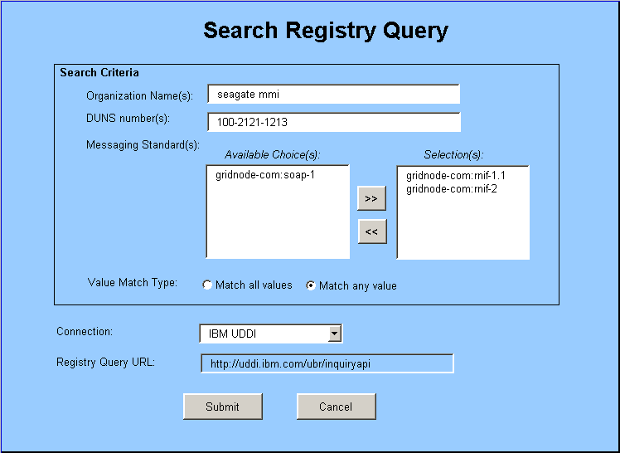
Figure 3 Search Registry Query

User Interface Requirements for Display Search Results

Figure 4 shows the UI concept of the function for displaying search results and configuring partner. The following paragraphs explain the requirements in more detail.

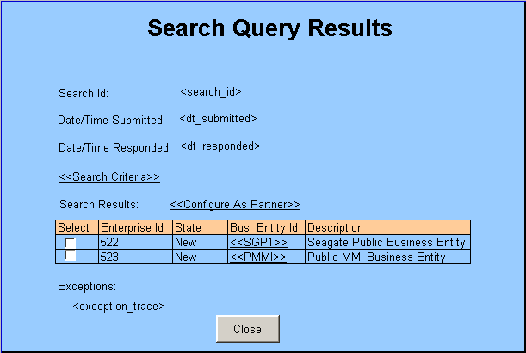
Figure 4 Search Query Results
Entry Conditions:
User selects a Search Registry Query to view from the Search Registry page.

Inputs & Interface Processing Requirements:

Search Id: Displays the search id of the Search Registry Query.

Date/Time Submitted: Displays the date and time of submission of the query.

Date/Time Responded: Displays the date and time when response returns.

<<Search Criteria>>: Hyperlink to view the Search Registry Criteria submitted.

Search Results: Displays the results returned from the search. Each unit is a Searched Business Entity

<<Configure As Partner>> | Configures the selected Searched Business Entity(s) as partner Business Entity(s) and Channel(s).
Select | Selects the Searched Business Entity row.
EnterpriseId | Displays the Enterprise Id of the Searched Business Entity.
State | Displays New/Own/Partner
<<Bus. Entity Id>> | Displays the Business entity Id. Contains a hyperlink to view the details of the Searched Business Entity.
Description | Displays the Business entity description.

Exceptions: Displays the exception stack trace if the search is not successful.

Close: Dismisses this page.

Exit Conditions:
Returns to the Search Registry page.

User Interface Requirements for Display Searched Business Entity

Figure 5 shows the UI concept of the function for displaying searched business entity and configuring partner. The following paragraphs explain the requirements in more detail.

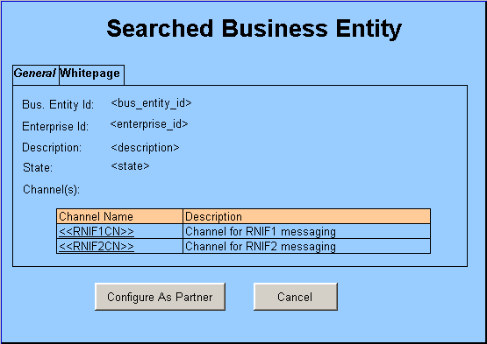
Figure 5 Searched Business Entity
Entry Conditions:
User clicks the <<Bus. Entity Id>> hyperlink in the Search Registry Query page.

Inputs & Interface Processing Requirements:

General: Displays the general details of the Searched Business Entity.

Bus. Entity Id | Displays the Business entity Id
Enterprise Id | Displays the Enterprise Id
Description | Displays the Business entity description
State | Displays New/Own/Partner
Channel(s) | Displays the list of Channel(s) associated to the business entity.
<<Channel Name>> | Name of the Channel. Contains a hyperlink to view the details of the Channel.
Description (under Channel(s)) | Description of the Channel.

Whitepage: Displays the white page details of the Searched Business Entity. Note: The details are the same as the white page details of Business Entity.

Configure As Partner: Configures the Searched Business Entity as partner Business Entity and Channel(s).

Cancel: Cancels the operation.

Exit Conditions:
Returns to the Search Registry Query page.

User Interface Requirements for Display Communication Channel

Figure 6-9 shows the UI concept of the function for displaying communication channel details of a Searched Business Entity. The following paragraphs explain the requirements in more detail.
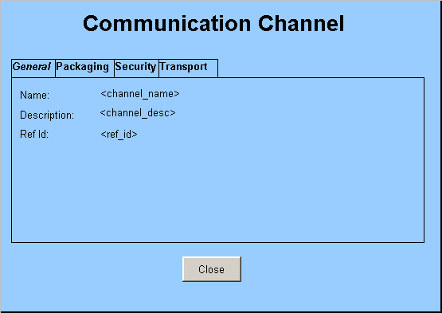

Figure 6 Communication Channel - General
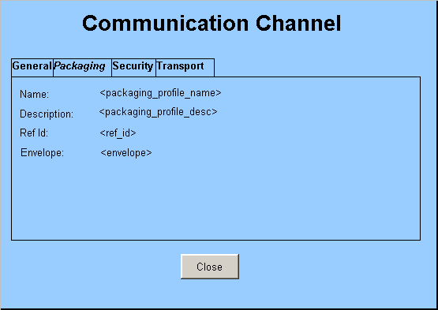
Figure 7 Communication Channel - Packaging

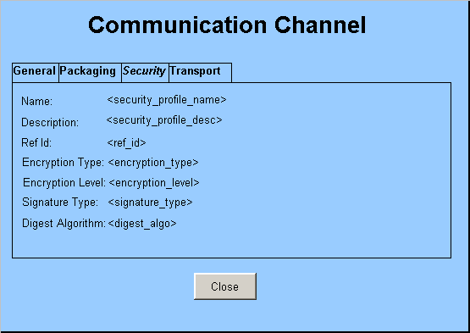
Figure 8 Communication Channel - Security

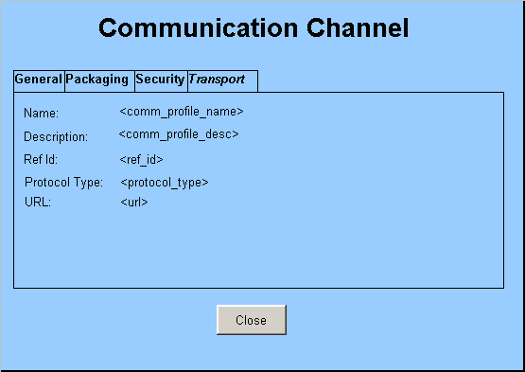
Figure 9 Communication Channel - Transport
Entry Conditions:
User clicks the <<Channel Name>> hyperlink in the Searched Business Entity page.

Inputs & Interface Processing Requirements:

General: Displays the general details of the Communication Channel.

Name | Displays the name of the Channel.
Description | Displays the description of the Channel
Ref Id | Displays the Ref Id of the Channel.

Packaging: Displays the packaging profile of the Communication Channel.

Name | Displays the name of the Packaging profile.
Description | Displays the description of the Packaging profile.
Ref Id | Displays the Ref Id of the Packaging profile.
Envelope | Displays the packaging envelope type.

Security: Displays the security profile of the Communication Channel.

Name | Displays the name of the Security profile
Description | Displays the description of the Security profile.
Ref Id | Displays the Ref Id of the Security profile.
Encryption Type | Displays the encryption type.
Encryption Level | Displays the encryption level.
Signature Type | Displays the signature encryption type.
Digest Algorithm | Displays the digest algorithm to use for signature.

Transport: Displays the transport profile of the Communication Channel.

Name | Displays the name of the Transport profile
Description | Displays the description of the Transport profile.
Ref Id | Displays the Ref Id of the Transport profile.
Protocol Type | Displays the type of transport protocol to use.
URL | Displays the end-point URL.

Close: Dismisses this page.

Exit Conditions:
Returns to the Searched Business Entity page.

Synchronizing Registry Information

GridTalk will allow the user to choose to:
- Upward Synchronization – synchronize own registry information to a registry
- Downward Synchronization – synchronize partner registry information from a registry

Upward Synchronization

This will update the Business Entity(s) information already published to a given registry.

To enable this synchronization, the Registry Object Mapping will contain a “deleted” flag which will be set (*) when:
- A channel has been removed from assignment to the Business Entity
- A channel has been deleted
- A business entity has been deleted
(*) This applies to all registries that the relevant entity has been published to.

The following Upward Synchronization process applies to all Registry Object Mapping records where “isPublished=true”:
- records that have been flagged “deleted” will result in the corresponding registry object being deleted from the registry.
- other records will result an update to the registry.

Downward Synchronization

This will update partner Business Entity(s) information that was inquired previously from the given registry.

The following Downward Synchronization process applies to all Registry Object Mapping records where “isPublished=false”:
- the registry object will be inquired from the registry and the corresponding entity will be updated.
- For Service registry object, new Service Binding(s) will result in creation of new Channel Info(s).
- When synchronizing Channel Info, if the Security Info is already persistent in database, no updating should be performed on the Security Info. This is to prevent overwriting the user modified encryption details.
- If the registry object cannot be queried from the registry, the Registry Object Mapping will be flagged ‘deleted’. The corresponding entity in GridTalk will be flagged “disabled” for use. Subsequent transactions should not take into account the “disabled” entities.

Implementation Issues

Partner Category

Should the partner Business Entity(s) and Channel(s) configured from registry be viewed as GridTalk or Non-GridTalk or both? Should be allow edit of these configured entities?

- View as GridTalk category
  - Do we create GridNode(s), what state should we use?
  - Do we create Master Channel(s)? If so, do we allow sending of document through this Master Channel?
  - How should we handle the proprietary processing that was based on the assumption that a GridTalk partner is “Activated”?
    - Connection status
    - Send direct/Upload to GridMaster/Local pending decisions
    - Activate after configured?
  - What to do if the published information does not belong to a GridTalk?

- View as Non-GridTalk category
  - Do we allow edit or deletion?
  - Do we populate the information of GridNode Id?

- View as GridTalk/Non-GridTalk, base on publish/configure option or automatically infer from published content
  - Problems of both 1 and 2

Recommendations:
For simplicity sake, “Non-GridTalk” category will be used by default for partner Business Entity(s) and Channel(s) configured in this way.
However, for future enhancement, the category can be determined based on:
- if the “enterpriseId” indicates an existing Active GridNode, then the “GridTalk” category will be used.
- otherwise, “Non-GridTalk” category will be used.
Then, if activation happens after the Business Entity have been configured as “Non-GridTalk”, the Business Entity will be “upgraded” to “GridTalk” category.

Downward Synchronization Scheme

What should be the scheme for resolving the removed registry information during downward synchronization?

- Delete the entities
  - How to handle the associations to these deleted entities?

- Mark the entities as “disabled”
  - How to disable associations to these disabled entities?

- Reflect the entities as “deleted” in description
  - How to prevent discovery of problems during processing?

Recommendations:
In general case, the entities could be marked “disabled” for transactions. The document processing logic needs to take care of not allowing “disabled” Business Entity(s) to receive/send documents.

Registry Provider API

What registry provider API to use?

- WSRA
  - Too simplistic, does not provide enough API to achieve what we want
  - Timeline for upgrade may not fit
  - Political issue

- JAXR
  - Can achieve what we want
  - Abstract the registry type
  - Reliability of reference implementation of JAXR-UDDI provider
  - More complex information model than UDDI – may not relate as straightforward.

- UDDI4J
  - Tied to a particular implementation
  - Cannot be used with other registry type e.g. ebXML
  - Implements the UDDI information model – straightforward to understand

Recommendations:

The GridTalk Business Registry will be designed in such a way different registry provider API can be easily plugged in.

Note: JSSL has upgraded the Service Registry in WSRA to provide a more sophisticated set of API. Due to time constraint, this may or may not be included in first cut delivery of the feature.

Appendix A: Mapping of Registry Information Models

GridTalk model | WSRA model | JAXR Information Model | UDDI Information Model
BusinessEntity | Business info | Organization | BusinessEntity
 | OrgId | key.id | businessKey
 |  |  | authorizedName
description | OrgName | name.value | defaultNameString
whitepage.busDesc | OrgDesc | description.value | defaultDescriptionString
 |  | services | businessServices
 |  | classifications | categoryBag
 |  | users | contacts
 |  | externalLinks | discoveryURLs
 |  | externalIdentifiers | identifierBag
whitepage |  | primaryContact (User) | contacts[0]
whitepage.contactPerson | PersonName | primaryContact.personName.fullName | contacts[0].personNameString
whitepage.tel | Telephone | primaryContact.telephoneNumbers[0].areaCode + countryCode + number + extension | contacts[0].phoneVector[0].text
whitepage.fax
whitepage.email | Email | primaryContact.emailAddresses[0].address | contacts[0].emailVector[0].text
 |  | primaryContact.url | operator
whitepage |  | postalAddress
whitepage.language
 | Service Info | Service | BusinessService (of BusinessServices)
 | ServiceId | key.id | serviceKey
 | OrgId | providingOrganization.key.id | businessKey
 | ServiceName | name.value | defaultNameString
 | ServiceDesc | description.value | defaultDescriptionString
 |  | serviceBindings | bindingTemplates
 | ServiceBinding | serviceBindings[0].description.value | bindingTemplates[0].defaultDescriptionString
 | AccessURI | serviceBindings[0].accessURI | bindingTemplates[0].accessPoint.text
 |  | ServiceBinding | BindingTemplate (of BindingTemplates)
 |  | key.id | bindingKey
 |  | description.value | defaultDescriptionString
 |  | accessURI | accessPoint.text
 |  | specificationLinks | tModelInstanceDetails
 |  | SpecificationLink | TModelInstanceInfo (of TModelInstanceDetails)
 |  | key.id | tModelKey
 |  | description.value | defaultDescriptionString
 |  | usageDescription.value | instanceDetails.defaultDescriptionString
 |  | usageParams | instanceDetails.instanceParams.text
 |  | externalLinks[n] | instanceDetails.overviewDoc
 |  | ExternalLink | OverviewDoc
 |  | description.value | defaultDescriptionString
 |  | externalURI | overviewURLString
 |  | Classification | KeyedReference (CategoryBag)
 |  | concept.key.id | tModelKey
 |  | classifiedObject.name.value | keyName
 |  | value | keyValue
UserAccount |  | User | Contact (Contacts)
 |  | description.value | defaultDescriptionString
name |  | personName.fullName | personNameString
 |  | postalAddresses | addressVector
email |  | emailAddresses | emailVector
phone |  | telephoneNumbers | phoneVector
 |  | useType | useType
 |  | url (webpage)
WhitePage |  | PostalAddress | Address
 |  | postalScheme.key.id | tModelKey
 |  | slot(SORT_CODE).values | sortCode
 |  | type | useType
 |  | slot(ADDRESS_LINE).values | addressLineStrings
city |  | city
country |  | country
zipCode |  | postalCode
state |  | stateOrProvince
address |  | street
 |  | streetNumber
poBox
 |  | EmailAddress | Email
 |  | address | text
 |  | type | useType
 |  | TelephoneNumber | Phone
 |  | areaCode + countryCode + number + extension | text
 |  | type | useType
 |  | url (electronic dialing)
 |  | ExternalLink | DiscoveryURL (of DiscoveryURLs)
 |  | externalURI | text
 |  |  | useType
WhitePage |  | ExternalIdentifier | KeyedReference (IdentifierBag)
 |  | identificationScheme.key.id | tModelKey
 |  | name.value | keyName
DUNS, GlobalSupplyChainCode |  | value (e.g. DUNS number) | keyValue
 | Category Info | ClassificationScheme | TModel
 | CategoryId | key.id | tModelKey
 | SchemeName | name.value | nameString
 | Description | description.value | defaultDescriptionString
 |  |  | authorizedName
 |  |  | operator
 |  | classifications | categoryBag
 |  | externalIdentifiers | identifierBag
 |  | externalLinks | overviewDoc
 | SchemeType?

